VT STORMWATER MANAGEMENT

FACT SHEET
Vehicle and Equipment Maintenance
This fact sheet outlines best management practices regarding vehicle and equipment maintenance, storage and spill response.
Potential Pollutants:

- Solvents (Paint Thinner)
- Brake Pad Dust
- Fuel (Gasoline, Diesel, and Kerosene)
- Antifreeze Coolant
- Battery Acid
- Lubricating Oil and Grease
- Brake Fluid
- Motor Oil
- Windshield Washer Fluid

Storage of Equipment:

- Store vehicles, equipment, and related fluids under covered areas to prevent exposure to precipitation.

Preventing Leaks:

- Do not dump any toxic substances or liquid waste on the pavement, the ground, or in adjacent areas draining to the storm drains.
- Inspect vehicles and equipment regularly for leaks.
- When possible, perform vehicle and equipment maintenance inside or in a covered area.
- When pouring liquids, use a funnel and place a tray underneath the vehicle to catch spills.
- When applicable, keep a drip pan under vehicles and equipment while performing maintenance.
- Promptly transfer used fluids to the proper waste or recycling drums. Do not leave full drip pans or other open containers containing used fluids open and exposed to precipitation.
- Recycle whenever possible. Store recyclable material in a non-leaking drum or covered container. This includes used motor oil, diesel oil, oil filters, and other vehicle fluids.
- Keep caps and covers on chemicals and storage materials and ensure all containers are properly labeled.

- Reduce the transportation of potential pollutants by only transporting the minimum amount of material required for maintenance.
- Use drip pans or absorbent material whenever grease containers are emptied.
- Never leave grease on the ground. Collect and properly dispose of as garbage in a sealed container.
- Inspect vehicles and equipment and replace faulty pumps and hoses immediately once a leak is discovered.

Responding to Spills and Leaks:

- If possible, move leaking vehicles or equipment indoors or into a covered area.
- Provide cleanup supplies near designated maintenance areas to facilitate immediate cleanup. Use dry cleanup methods (e.g., rag, damp cloth, or absorbent material) rather than hosing down the area.
- If the spill or leak is non-hazardous, attempt to contain the spill using a broom and/or absorbent material (absorbent sock). See Photo 1.
- Block any floor drains in the vicinity to prevent the spill from entering a floor drain.
- Properly dispose of all used cleaning supplies when cleanup procedures are complete.

NOTE:

If the spill or leak is significant and will reach the storm drain system, notify Environmental Health and Safety immediately at (540) 231-3600.

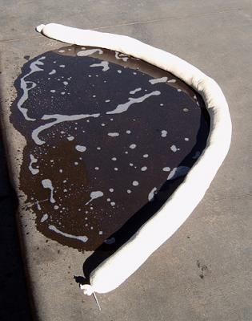
Photo 1: Absorbent Sock containing an oil spill.

